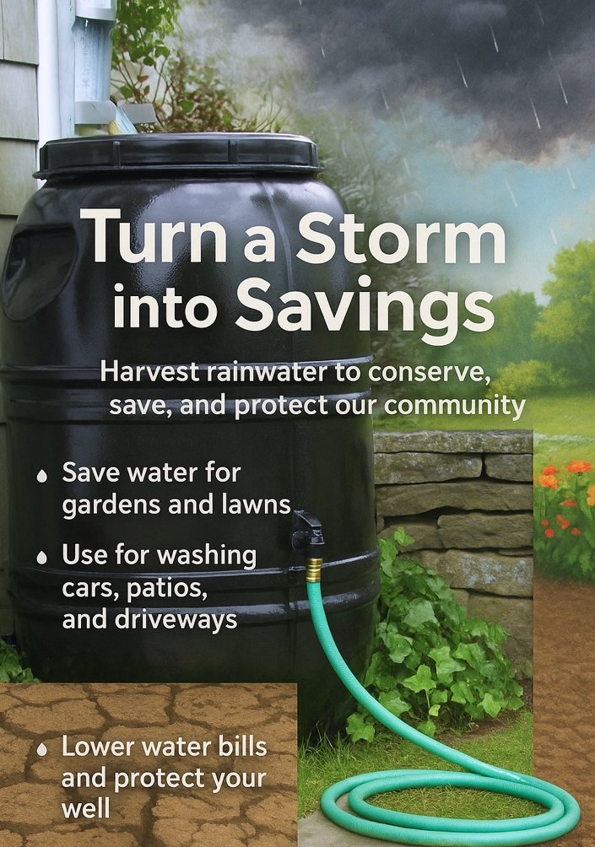
SALEM, NH
GREAT AMERICAN
RAIN BARREL PROGRAM 2026
CATCH IT — SAVE IT — USE IT
“Once the ground freezes,
we can’t recharge the
groundwater system until spring.
For people who rely on wells or
groundwater systems, that means
the risk of running short on water
through the winter months.”
NH State Climatologist, Mary Stampone.
According to the New Hampshire Department of Environmental Services, the summer of 2025 was the driest New Hampshire has experienced in more than a century. That reality is already hitting home for many families whose wells are already low — or dry. Homeowners with private wells are advised to monitor their water levels, limit nonessential use, and consider ways to capture rain before it’s lost to runoff.
Every Drop Counts — Rain Barrels benefit both communities and our planet by:
- Providing a clean, untreated water source that can be used for gardening and cleaning.
- Decreasing energy consumption and greenhouse emissions at water treatment plants.
- Reducing water bills by up to 40% and can save homeowners 1300 gallons of water annually.
- Using less water helps sustainably manage water as a global resource for future generations.
About The Great American Rain Barrel
- 100% re-purposed, food grade, UV protected and BPA free barrels. Produced in Massachusetts.
- Most durable rain barrels on the market: 3/16” wall thickness. Screen filtered to keep mosquitoes out.
- Will last for years when properly drained & stored for winter. Pay for themselves in one year.
- Several rain barrels can be linked together — an easy 5-minute setup.
- Available Colors: Forest Green, Earth Brown, and Nantucket Grey. Also available unpainted.
How to Purchase Your Rain Barrel
Rain Barrels are available for purchase by residents at the discounted price of $80-$89.00.
How to Order: https://www.greatamericanrainbarrel.com/community/, Select Town and State
Pickup: April 18th, 2026. Location TBA
Deadline: April 5th, 2026. Midnight.
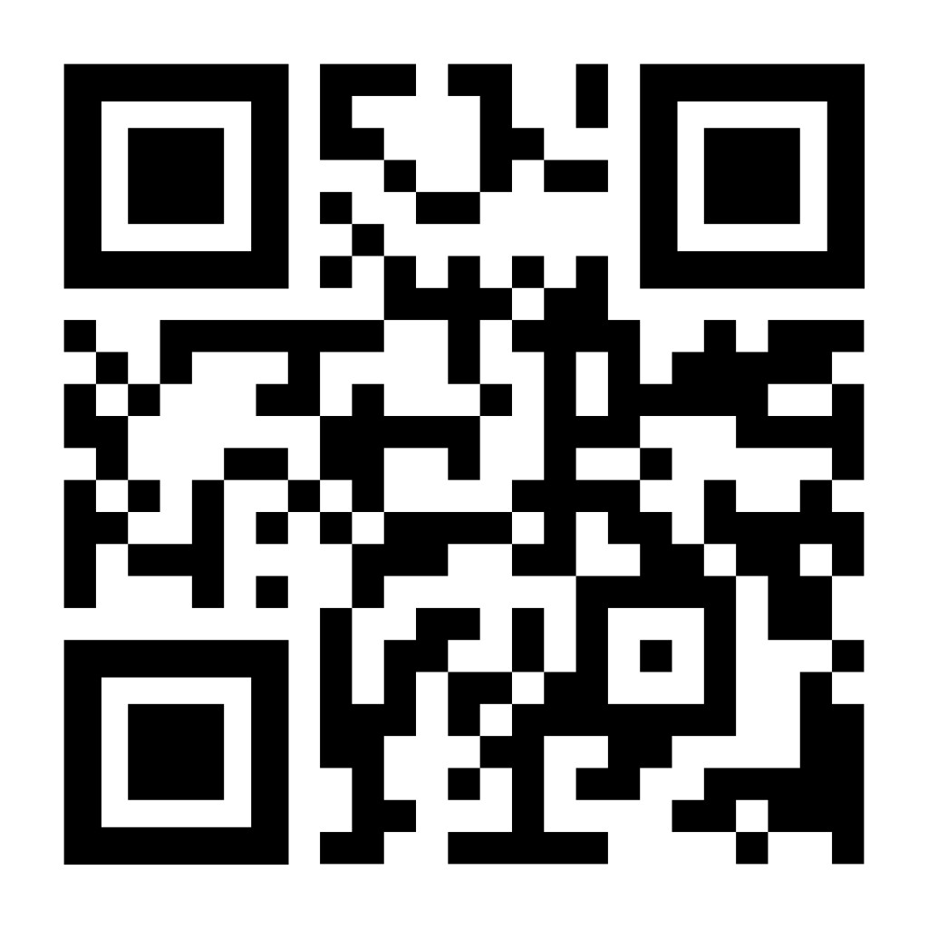
Or scan QR code:

